Sarath Prakash

[sarathprakashofficial@gmail.com](mailto:sarathprakashofficial@gmail.com%20) | +91 9947311713

*Pulikkottil house, Brahmakulam PO, Thrissur, Kerala*

*More details visit:* [*http://sarathprakash.com/*](http://sarathprakash.com/)

# Summary

*I have overall 9+ years of software development experience in IT industry. Successfully implemented more than 15 software projects, participating in full project life cycle. Scaling new heights of success and leaving a mark of excellence in assignments. A challenging career in Business Analysis and to be associated with a progressive organization which can provide me with a dynamic work sphere to extract my inherent skills as a Professional, use and develop my aptitude to further the organization’s objectives and attain my career targets in the progress.*

# Professional Highlights

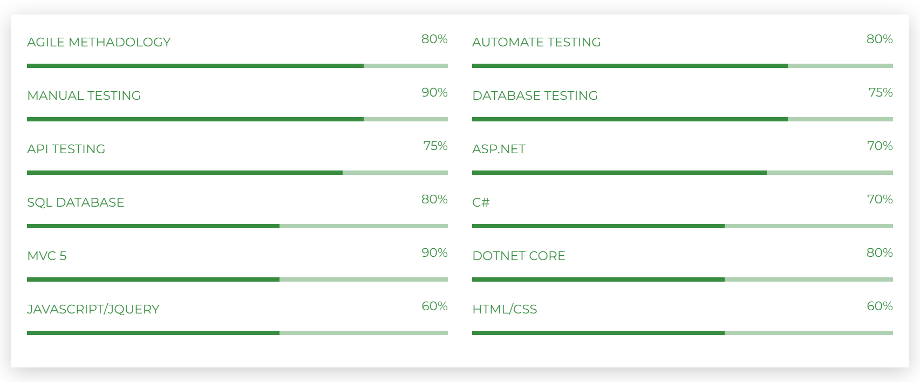

# QA Roles & Responsibilities

* 1. Identifying issues and risks in a timely manner on each environment
  2. Updating the regression pack for providing the best application coverage; supervising the Regression Team & ensuring timely delivery for each regression cycle
  3. Monitoring testing activities for ensuring the quality and functionality of assigned systems; ensuring timely & accurate test communication with Development Leads, Project Manager & Senior Management throughout the project life-cycle
  4. Tested penetration testing issues using Burp suite, Cross scripting attacks and fortify fixes
  5. Following the project life cycle methodology defined under the process framework; ensuring that customer deadlines are met.
  6. Experience in Agile process and methodologies.
  7. Involved in Test case review meetings, Scrum discussions, and Retrospective meetings.
  8. Experience in understanding business and testing requirements.
  9. Hands-on experience in Database testing

# Development Roles & Responsibilities

1. Requirements have been documented and get approval from the stack holders.
2. Creation of user stories for a sprint and thereby follow scrum methodology for development.
3. Done impact analysis on user stories and estimated time effort for the same
4. Took the responsibility on project by taking ownership and work all the PBI’s bugs, developments and deployment individually
5. Participated in solution development, contributed to client discussions and meetings on daily basis.
6. Met deliverables as per client expectation.
7. Identifying issues and risks in a timely manner; developing/implementing appropriate mitigation & contingency plans
8. Worked on fixing penetration testing issues, Cross scripting attacks and fortify fixes
9. Worked on technologies such as C#, dotnet core, MVC, Bootstrap, HTML, CSS, SQL Server JavaScript and jQuery.
10. Creating Database object such as tables and stored procedures.
11. Deployment in Azure and devops tools such as Team city and Octopus.
12. Follow Coding standards as a part of CMMI level standards.
13. Strong in creating static and dynamic websites for clients as per requirements.

# Experience

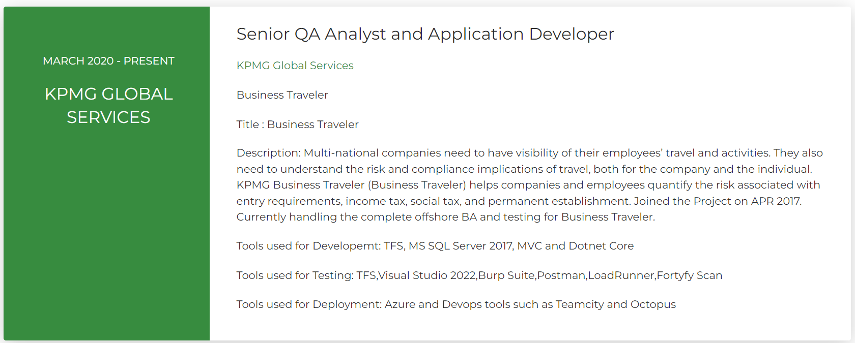

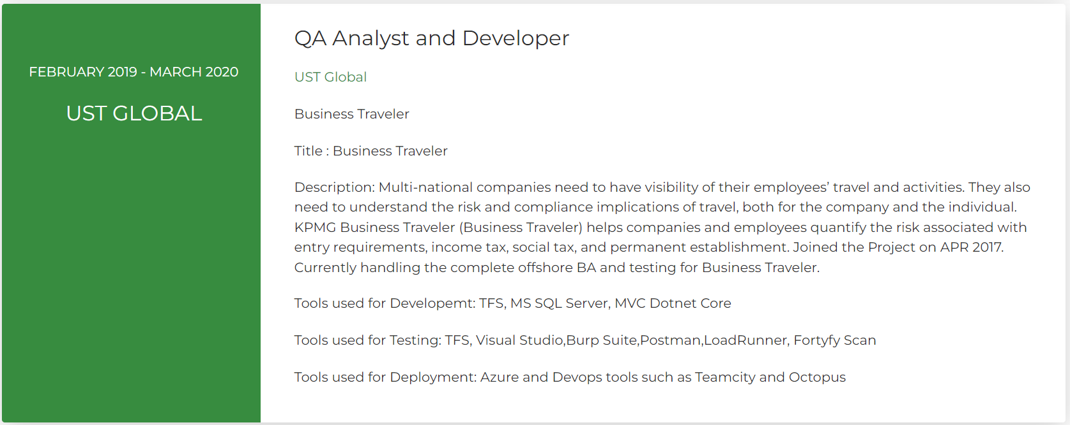

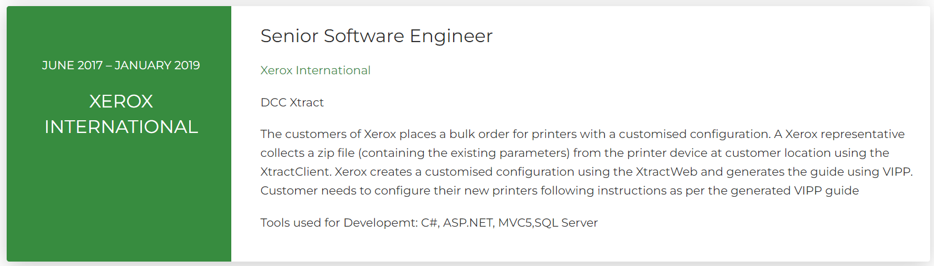

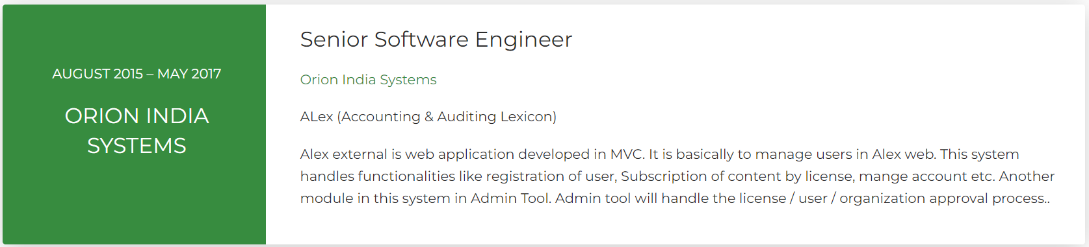

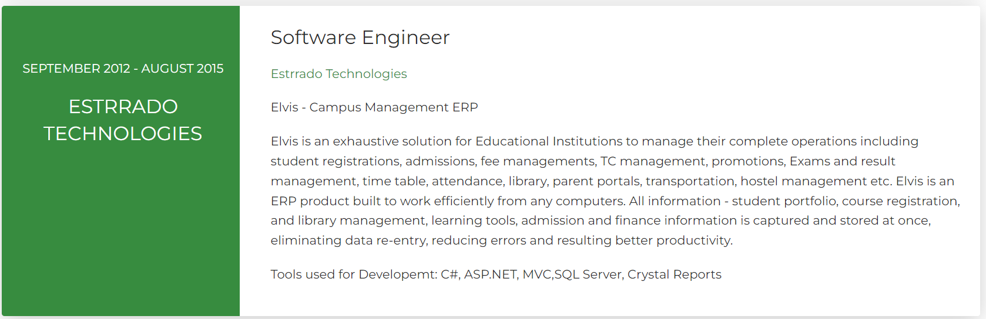

# Educational Qualifications

# 

# Certifications

1. **Microsoft Azure Fundamentals AZ-900**
2. **ISTQB - UK and Ireland testing Board**
3. **Power BI and Business Analyst**

**Contact Details**

**Mobile:**  +91 9947311713

**Email:** [sarathprakashofficial@gmail.com](mailto:sarathprakashofficial@gmail.com)

**LinkedIn:** linkedin.com/in/sarath-prakash-751a27229

**Website**: <http://sarathprakash.com>

**Skype:** sarathnmz

**DUF** **Number:** 2022 053514 06

**Norway Visa Number:** 004168204

**Personal Details**

**Father’ Name:**  Jose Prakash

**Passport:** V4106904

**Nationality:** Indian

**Marital Status:** Married

**Language**: English

**DOB**: 23/03/1989

**Declaration**

I hereby declare that the above given particulars are true to the best of my knowledge and belief.

(Sarath Prakash)